Agile Report for OOSD Group Assignment
Agile development defines itself as a set of principles and values, instead of a methodology or a specific process. The agile manifesto is very simple and believes in the importance of interactions and individuals rather than tools and processes. Therefore, agile development is more focused on adapting to changes, over following a strict plan. This ethos was essential during our project as we were working towards a deadline with many unpredictable programming tasks along the way. The agile method allowed us to respond frequently and adequately to any issues that arose.

During the initial phase of our development we were required to utilise use case diagrams, class diagrams and sequence diagrams. These diagrams helped us to successfully identify system users and avoid building the wrong solution for the specification. Use cases were helpful to identify all of the actors in the scenario as well as the functions required and the associations between them. Next, we utilised class diagrams to distinguish the relevant nouns from the scenario that represented the classes needed for this application. These diagrams help to find the attributes and entities of each class in addition to the associations between classes. Finally, we used sequence diagrams to model the interactions between the classes in a single use case. These models are useful for identifying how the different parts of a system interact with each other and the order in which the interactions occur.

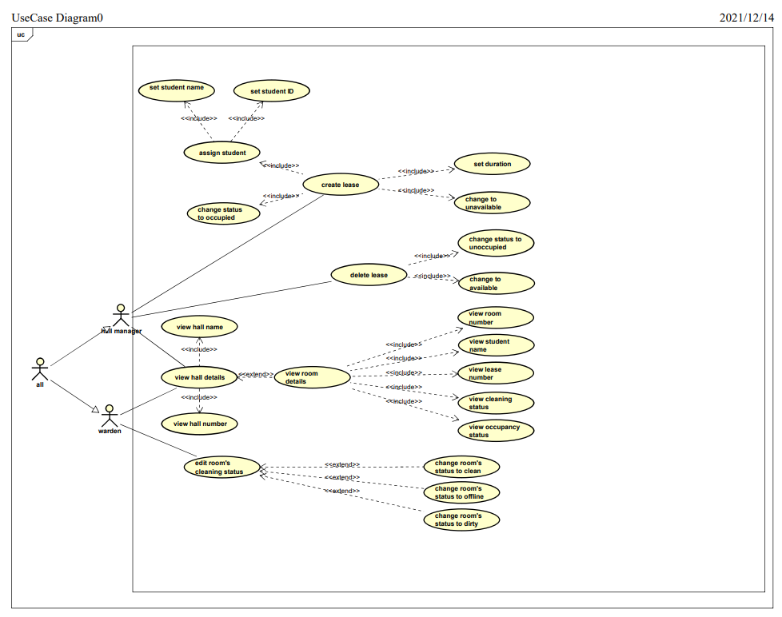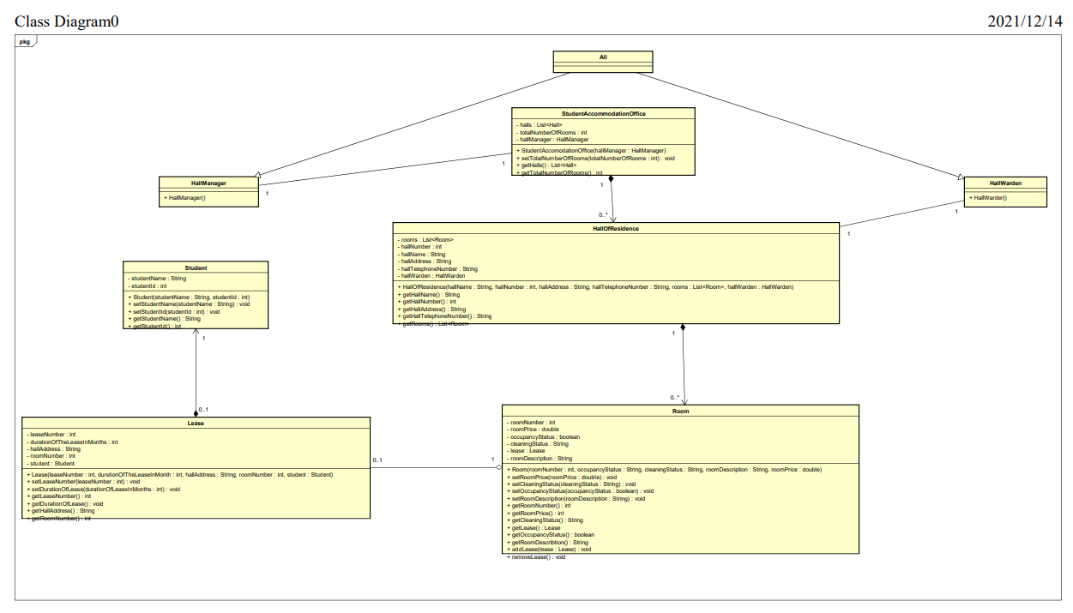
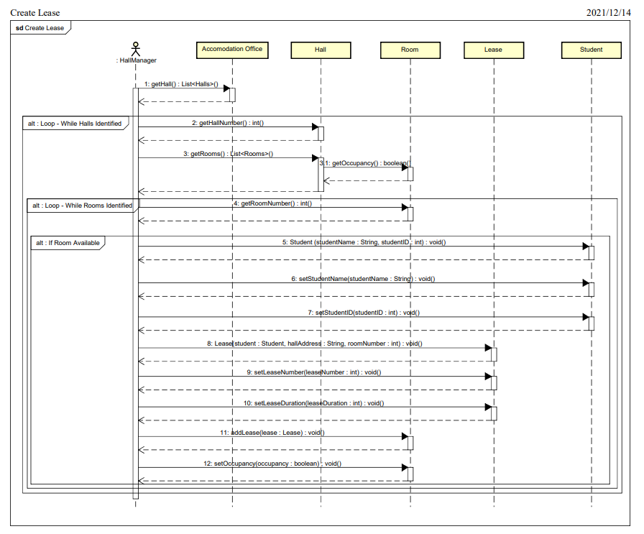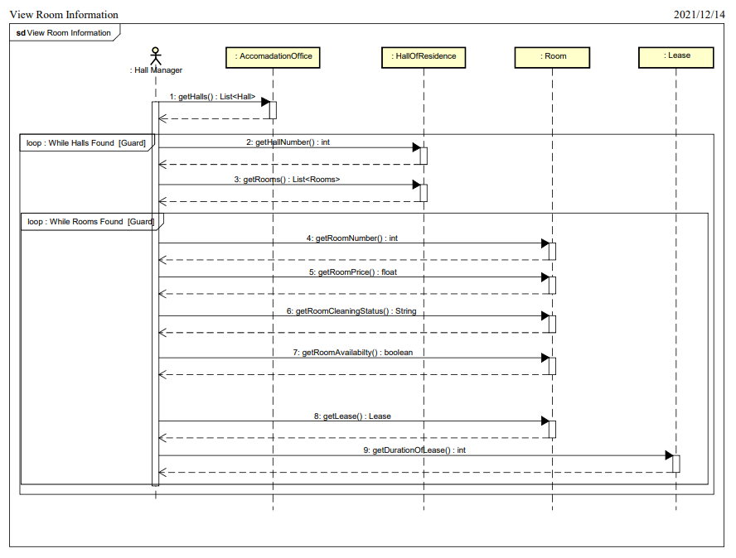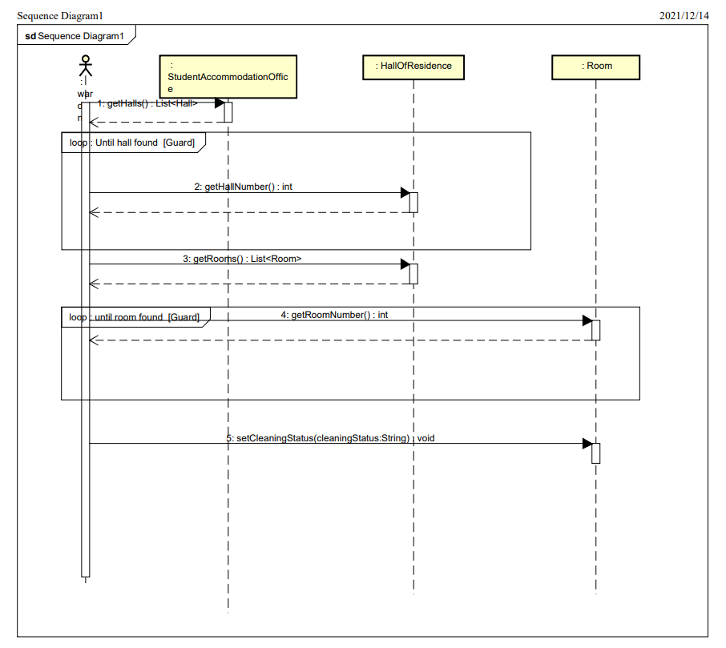

Before agile development, highly detailed processes were often used that defined exactly how software was to be created (Shore and Warden 2021). This meant that such processes did not allow for change or problems that could occur later down the line. However, agile works by allowing for change between project phases, as well as continuous development and feedback throughout the project. This technique thrives on concepts such as face to face meetings and collaborative team meetings. Therefore, a successful agile project will require incremental meetings to discuss the progress and highlight any issues found in the previous phase of development. As a team we met weekly, either in person or online, to discuss any issues with the application and divide responsibilities between the team. Flexibility is one of the main advantages of agile development and several working practices can be implemented to aid this. For example, pair programming can allow for instant feedback on code and increase productivity as developers can switch roles periodically. This adaptability allows for change without affecting the overall target which can be very beneficial in situations where unexpected problems may occur.

Our main objective was to practice simplicity to avoid the structure of the system being overly complex. Agile practices believe strongly in simplicity as it allows for change in the requirements over time, which is a crucial factor of software development. The popularity of this working style has increased within the software industry in recent years, with newer software development models continuing to include more ideas based on iterations and feedback (Sheerer and Springerlink, 2017). By setting interim deadlines and meetings, agile development reduces the risk of mistakes and setbacks that may occur during the project. These collaborative meetings ensure that all members are clear on their individual roles and tasks. I believe that this method helped to increase productivity throughout the project.

References.
- Scheerer, A. & SpringerLink (Online service) 2017, Coordination in Large-Scale Agile Software Development: Integrating Conditions and Configurations in Multiteam Systems, Springer International Publishing, Cham.
- Shore, J. & Warden, S. 2021, The Art of Agile Development, 2nd Edition, O'Reilly Media, Inc.

